**DSA Assignment – 23rd July**

**Name – Karan Joshi**

**Roll No. – 23/11/EC/036**

**Leetcode Id – Karan_Joshi068048**

**Geeksforgeeks Id – wwwjoshikaran3424**

**Github Repo Link -** [**https://github.com/KaranJoshi101/urban-octo-robot/**](https://github.com/KaranJoshi101/urban-octo-robot/)

DSA-Section -

Question 1: Search in Rotated Sorted Array

Submission Screenshot:

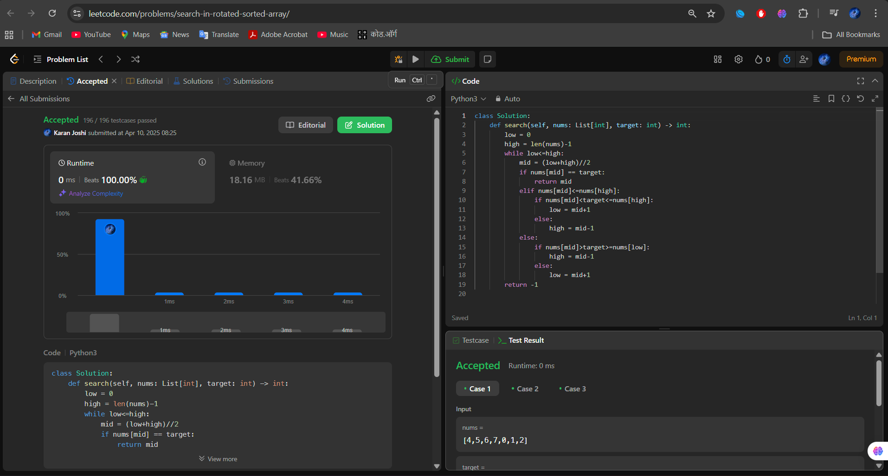

Question 2: Find Peak Element

Submission Screenshot:

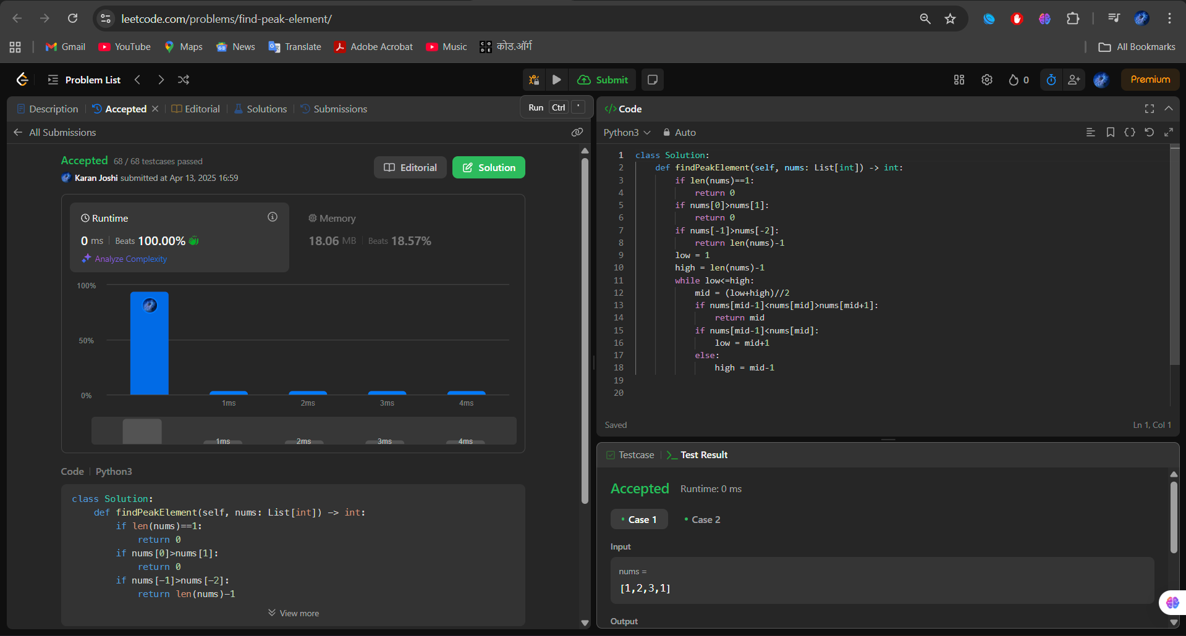

Question 3: Allocate Minimum Pages

Submission Screenshot:

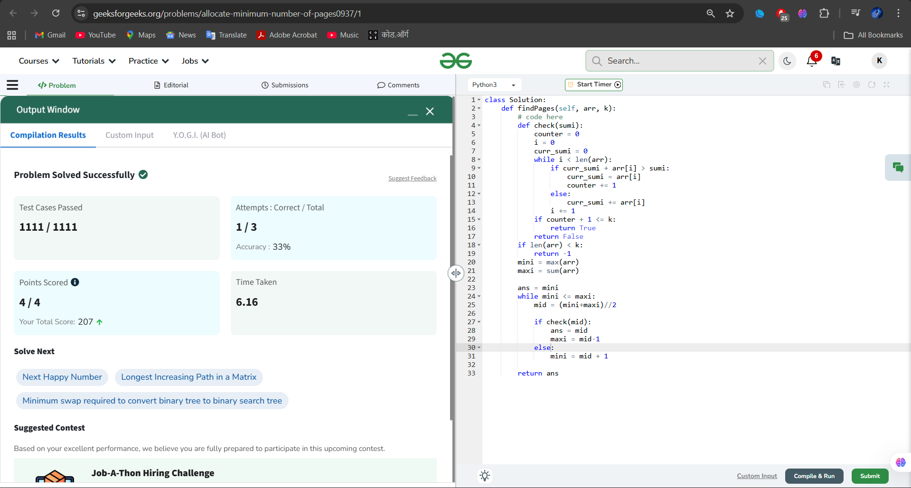

Question 4: Minimum Number of Days to Make Bouquets

Submission Screenshot:

